PHASE 3 – PROJECT DESIGN

3.1 Introduction
Project design defines the overall structure of PocketSmart AI and explains how the frontend, backend, database, and recommendation components interact.

3.2 System Architecture
The application follows a web-based architecture in which the user interacts with the frontend, while the FastAPI backend processes requests and communicates with the database and recommendation logic.
System Architecture:
User → Frontend → FastAPI Backend → Recommendation Logic / Database → Response → Frontend
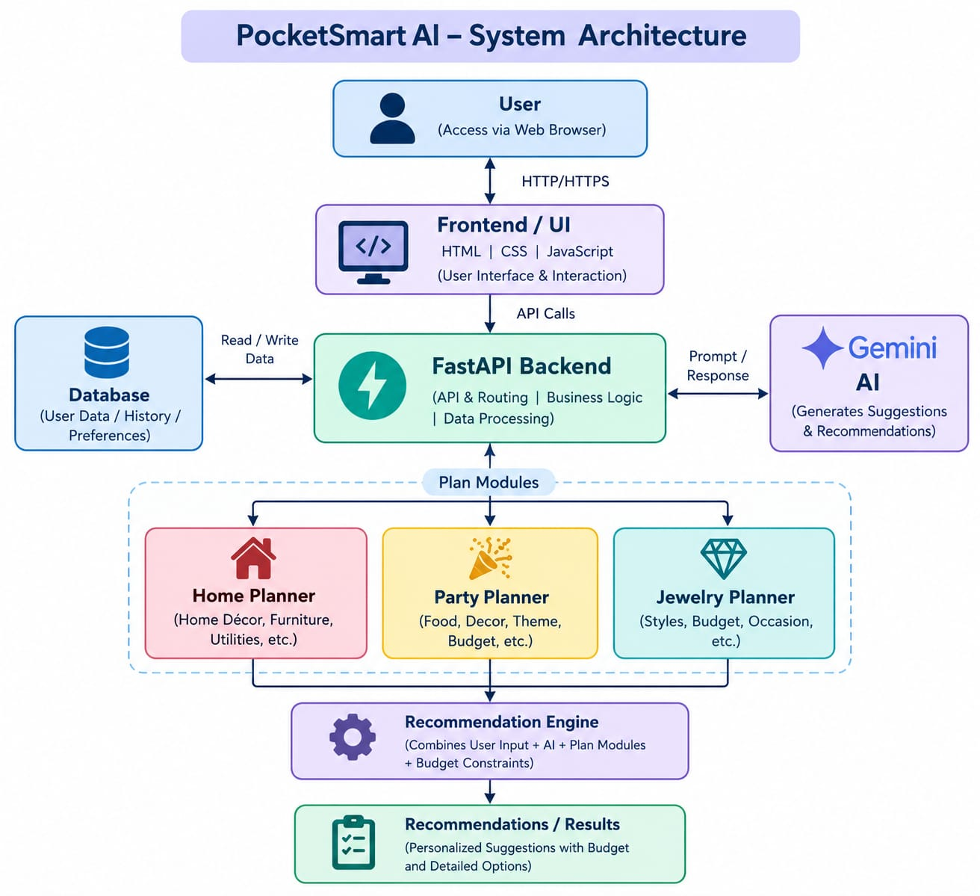

3.3 Component Description

Frontend
The frontend provides the interface through which users enter information and view results.

FastAPI Backend
FastAPI manages application routes, processes requests, communicates with application logic, and returns responses.

Recommendation Module
The recommendation component processes the submitted requirements and budget and produces recommendation results.

Database
SQLite stores application data required for users and recommendation/history-related information.

3.4 Project Structure
The project is organized into separate files and directories so that application components can be maintained efficiently.
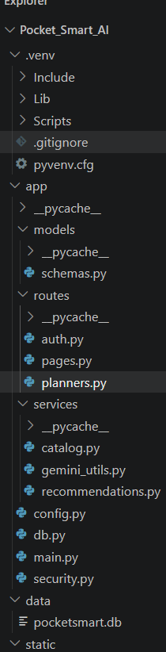
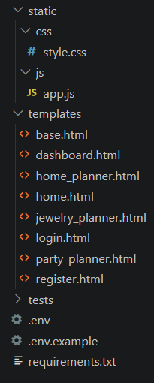

3.5 User Flow
The basic user flow is:
Login/Register → Dashboard → Get Started → Enter Budget & Requirements → Get Recommendations → View Results → Recent Plans/History
Login / Register
↓
Dashboard
↓
Get Started
↓
Enter Budget & Requirement
↓
Get Recommendation
↓
View Result
↓
Recent Plans / History

3.6 Database Design
The application uses SQLite as its database. Database tables are used for storing user and recommendation-related information.
The database structure supports the application's authentication and recommendation/history functionality.
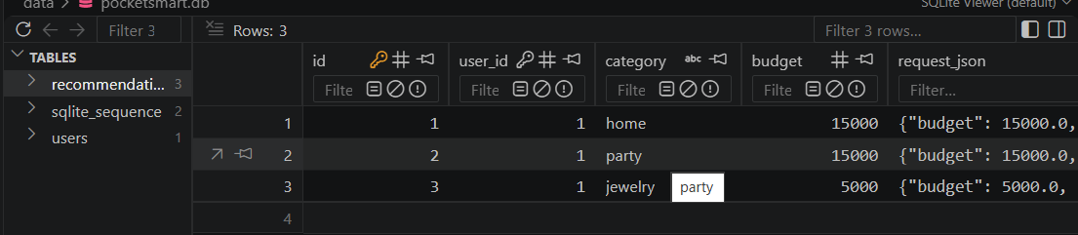

3.7 UI Design
The interface is designed to provide a simple sequence for the user:
- Authentication.
- Dashboard access.
- Budget and requirement entry.
- Recommendation generation.
- Result display.
- Access to previous plans.
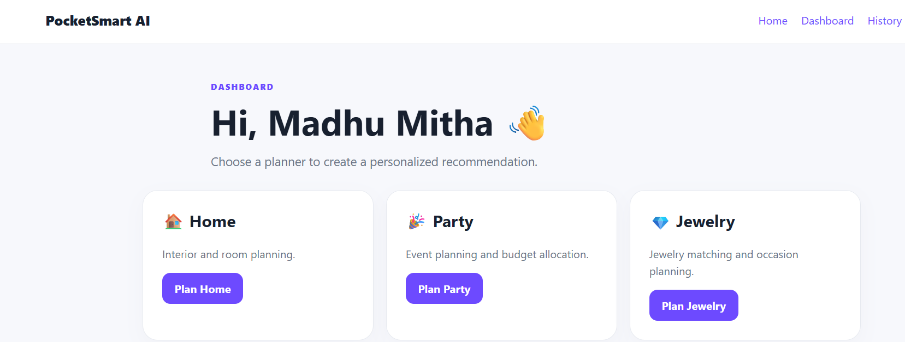

3.8 Data Flow
The data flow can be represented as:
User Input → Backend Request → Processing → Database/Recommendation Logic → Generated Result → User Interface
User Input
↓
Backend Request
↓
Processing
↓
Database
↓
Recommendation Logic
↓
Generated Result
↓
User Interface

3.9 Design Summary
The design provides a modular structure that separates user interaction, backend processing, database storage, and recommendation generation

